**Pymaceuticals Observations**

1. Two out of 9 drugs were effective in reducing Tumor Volume and Metastatic Spread; Capomulin and Ramicane.

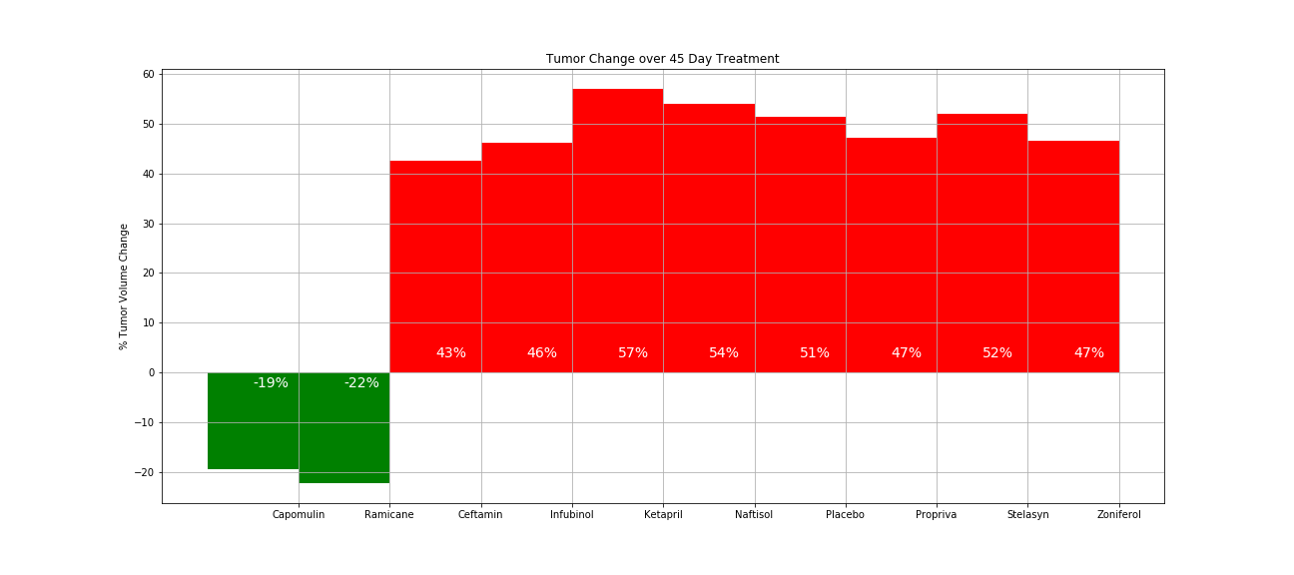

1. The reduction in Tumor Volume and Metastatic Spread led to much higher survival rates for Capomulin and Ramicane compared to the other drugs.

1. Of the other drugs, only Ceftamin had better performance versus the Placebo that was outside the standard error

